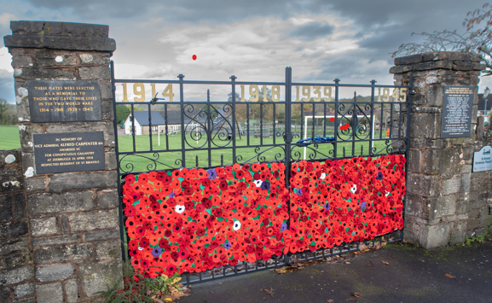

Lest We
Forget.....

An Act of Remembrance
will be held on

Sunday 8th November 2026
10.45a.m. at the War Memorial Gates, St. Briavels.

The Ceremony will include the laying of wreaths, and the Reverend Rees will lead the Service of Remembrance .

Also planned :
- The Flag will be raised in the early morning of the 8th and left raised until 11am on the 11th - Remembrance Day -when it will be lowered down for two minutes. It will then be raised to full mast for the remainder of Remembrance Day. All are welcome to attend this.

- Prior to Sunday’s ceremony on 8th the 1st St Briavels Scouts will parade from the school to the Memorial gates where they will join the service to lay a wreath.

- As part of the service the schoolchildren of St Briavels Primary School will read their poems.

- Teas & Coffees will be available at the Pavilion afterwards.

ST BRIAVELS PARISH COUNCIL

