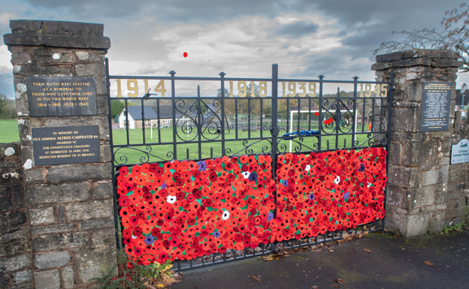

Lest We
Forget.....

An Act of Remembrance
will be held on

Sunday 9th November 2025
10.45a.m. at the War Memorial Gates, St. Briavels.

The Ceremony will include the laying of wreaths, and this year The Reverend David Rees will lead the service of remembrance .

Also planned :
- The Flag will be raised in the early morning of the 9th and left raised for the rest of the day and until 11am on the 11th - Remembrance Day -when it will be lowered down for two minutes. It will then be raised to full mast for the remainder of Remembrance Day.

- Prior to Sunday’s ceremony on 9th the 1st St Briavels Scouts will parade from the school to the Memorial gates where they will join the service to lay a wreath.

- The service will be followed with Poems from the schoolchildren of St Briavels Primary School.

- Teas & Coffees will be available at The Assembly Rooms afterwards

ST BRIAVELS PARISH COUNCIL

