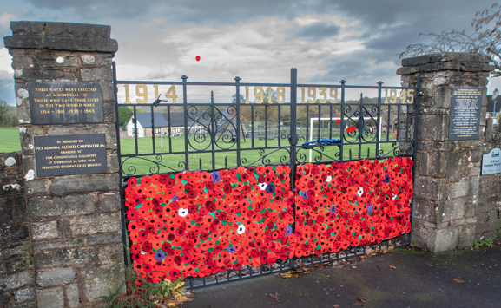
Lest We
Forget.....

An Act of Remembrance
will be held on

Sunday 9th November 2025
10.45a.m. at the War Memorial Gates, St. Briavels.

The Ceremony will include the laying of wreaths , readings, and a service of Remembrance .
Teas & Coffees will be available at The Assembly Rooms afterwards
ST BRIAVELS PARISH COUNCIL

